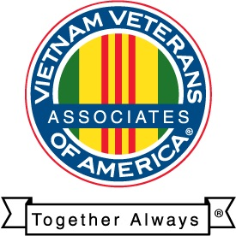
(enter your chapter contact address)

Associates of Vietnam Veterans of America Chapter (your chapter #), Inc.

(Date)

Subject: Group Exemption under Associates of Vietnam Veterans of America, Inc. IRC 501 (c) 3.

The Associates of Vietnam Veterans of America Chapter (your chapter #), Inc. agrees to abide by the Articles of Incorporation and By Laws of the National Associates of Vietnam Veterans of America, 8719 Colesville Rd., Silver Spring MD 20910. We further agree to fall under the supervision of the National Corporation, abide by their policies and procedures as well as their disciplinary policies in existence now and in the future.

Signed this ____ day of _____________, 20___
Associates of Vietnam Veterans of America Chapter (your chapter #), Inc.

_______________________________
(President’s Name)
AVVA Chapter (chapter #) President
(Contact Address)
(City state zip)
(Phone Number)

