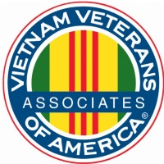*ASSOCIATES OF VIETNAM VETERANS OF AMERICA, INC.*

AVVA National Awards Committee Co-Chair

2021

As Co-Chair for AVVA National Awards Committee in 2021, we were still affected by the pandemic.

We sent out our various notices across the board to receive submissions to award our AVVA members, yet we received only two nominations.

We received only two nominations, one for a Fellowship Award and one for the Cathy Keister Award.

Together with Rick and myself, we examined and revised the criteria portion for these awards. This allows our members to know exactly what we are looking for in a nominee and they can focus on the work being done by our members.

All the best to the nominees. Let’s recognize our members!

Respectfully,

Teresa Rangel Rick Talford

AVVA National Awards Committee AVVA National Awards Committee

Co-Chair Co-Chair