April 2023

The website has been and continues to be updated with convention and national election information. Currently we have listed all the candidates for national offices, with their campaign information, and the general convention information. Convention information will be continually updated as data is provided, so please keep checking the AVVA Website. You can go to the main web page: [www.avva.org](http://www.avva.org) or you can go to one or both of these individual pages:

[www.avva.org/convention.html](http://www.avva.org/convention.html) and/or

[www.avva.org/elections.html](http://www.avva.org/elections.html)

The AVVA website contains a good deal of information for both AVVA and VVA. Below are a few of the pages that would be of most benefit to newer members, as well as all others.

<https://www.avva.org/> (scroll to the many links as well as use the main menu line)

<https://www.avva.org/membership.html>

<https://www.avva.org/minutes.html>

<https://www.avva.org/forms.html>

<https://www.avva.org/training.html> (Watch for new videos coming soon!)

<https://www.avva.org/news.html>

There are many more pages of good information. Visit the website soon!

We are also in the process of creating MP4 videos of our training power point presentations for those who do not have a program or the equipment to run a power point at a gathering. The MP4 files should play automatically on any device that is less than about 6-7 years old. Many older computers and laptops can also run these videos. This, we hope, will make it much easier to share training with others in your chapter or state. Visit our Training & Education web page for continuing materials. (<https://www.avva.org/training.html> )

AVVA has a Face Book page as well. It is under used at this time, but is a very good resource for members sharing information across the country. This page can be found at: <https://www.facebook.com/AssociatesofVi1>

That is it for now. Hope to see you at the National Convention!

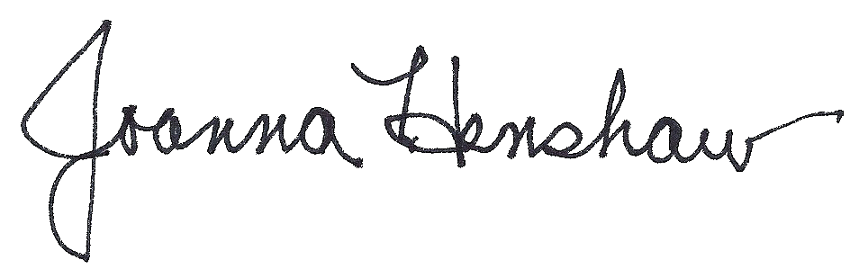

Joanna Henshaw, Website Committee Chair